OOP Coursework Implementation Task
Background Recap
Different Coat is a well-established paint and decorating business stocking all indoor/outdoor paints. The business is open to the public and trade customers.
Recently staff have been overwhelmed with a specific request from all customers. This is to determine how much paint is required to paint a specific room. Customers do not want to purchase too much or too little paint to complete a painting job. Customers want to know this initially before committing to purchasing specific volumes of paint. This information can be relayed to them on or after the calculation has been completed.
Preplanning
Please refer to the class diagram (Appendix 1) or your own created in previous task to help form the programming solution to all the tasks below.
Task 1a – Base Class
Initially, create a new Java project within Eclipse and name appropriately if not already done so.
- Create a base class that has the following information recorded about paint calculations:
- Customer Type
- Customer address
- Customer telephone number
- Surface area
- Room shape
- Height
- Width
- Within the base class, create two constructors containing the following information:
- A constructor that will process customer type, customer address, telephone number and surface area
- A constructor that will process customer type, customer address, telephone number, room shape, height and width
- Within the base class, create a method to be the base to work out the coverage for different customer types
- Create necessary getter(s)/setter(s) for class
- Within the base class, create a toString() method to aid testing and to allow further overriding within derived classes

Task 1b – General Public Class
- Within your existing Java project created previously, code a derived class that has the following additional information recorded about the general public
- Customer Name
- Create a constructor containing the relevant information to process a paint calculation for specific customer
- Create necessary getter(s)/setter(s) for class
- Override the toString() method from the base class and provide a detailed breakdown of calculation details including customer name, room shape, address, telephone number and paint coverage calculation
- Add the implementation to the coverage method inherited from the base class.
Task 1c – Trade Class
- Create a derived class that has the following additional information recorded about trade customers
- Trade Name
- Create a constructor containing the relevant information to process a paint calculation for specific customer
- Create necessary getter(s)/setter(s) for class
- Override the toString() method from the base class and provide a detailed breakdown of calculation details including trade name, address, telephone number and paint coverage calculation
- Add the implementation to the coverage method inherited from the base class
Task 2 – Utilities Classes
You are required to code two utility classes as per class diagram. These are essential classes required to store various constants to be used within the solution and to deal with reading and storing of information effectively from a file.
Task 2a – Constant Class
Within the Java project created for task 2, code a constants class that will be used to store the key information required to work out the core calculation to paint different shapes of rooms. For clarity, room shapes will be square, rectangular and cylindrical. Note that all calculations will be in square feet. There will be various constants used within the various paint calculations and therefore these must be stored within a constants class.
Task 2b – Helper Class
- Use the csv file initially created from first assignment that contained a suitable number of records of customer details based on customer types identified. This should include only positive tests i.e., tests that will pass based on correct customer types, measurements etc.
- Create a method within the helper class that will open and read the file and store each record within an array list. Make sure this method has the capability to return this array list when required

Task 3 – Demo Class
Create a class with a main method that will initially:
- Call a method to explain the system developed including the different customer types and how the system works processing the data file containing customer details and outputting detailed paint calculations
- Call a method to loop through the array list created from the file, instantiating appropriate customer objects and displaying appropriate output.
Task 4 – Testing
You are required also to test the demo class you have created and provide documentation.
- Prepare a test plan with test cases containing suitable test data from file created and create the expected results. Please use the template (Ref: Test Plan Test Log Template.xlsx) on Teams
- Test the software; either use TestNG to log results of tests or manually log within test plan provided. It is important to compare the actual results to the expected results keeping a log for each test. Record any amendments made to resolve any logical or run-time errors found

Task 5 – Documentation
You are required to provide documentation that will:
- Support the maintenance of the software moving forward
- Evaluate the software created and provide a self-evaluation initially followed by evaluations from fellow peers (minimum 2). Make recommendations based on these evaluations for improvements to the software
Student Notes
Initially, please always refer to Teams for notes, guidance, templates etc. for successful completion of this assignment.
You should produce the following for review:

- High-level overview of project solution illustrating key packages and classes
- Program listings of each class with appropriate comments throughout
- A copy of original data file created
- Test data, test cases, expected results, actual results and the log of testing
- Evidence of successful software execution via console output
- Documentation relating to future software maintenance and self and peer evaluations

Assignment Criteria
3.1 | Clarify relationships between objects to implement design requirements identified in AC2.2
3.2 | Configure object behaviours using control structures to meet design algorithms
3.3 | Use an Integrated Development Environment (IDE) to develop the programming solution to meet design requirements identified in AC2.2
3.4 | Demonstrate how to implement error handling and reporting to enable correct functionality
4.1 | Test the object orientated programming solution developed in AC3.3.
4.2 | Analyse test results obtained in AC4.1 against expected results, identifying possible discrepancies
4.3 | Create onscreen help to assist the users of the object orientated programming solution developed in AC3.3
4.4 | Create user documentation to assist with support and maintenance of the object orientated programming solution developed in AC3.3.
4.5 | Evaluate feedback on the object orientated programming solution developed in AC3.3 and make recommendations for improvements.

Reference Purposes to aid development as described above:
2.2 | Create a design specification for an object oriented programming solution to a given problem

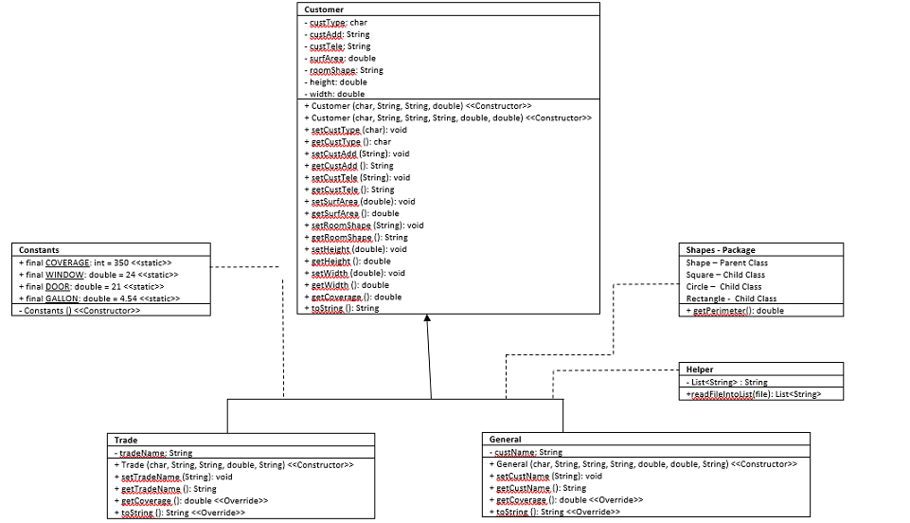
Appendices – Appendix 1 Different Coat Completed Class Diagram

